Botany Staff:-
Photo | Name | Designation | Qualification | Experience
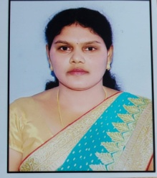 | Smt. Battu. Shantha Kumari | Lecturer | M.Sc., B.Ed., M.Phil | 15 Years
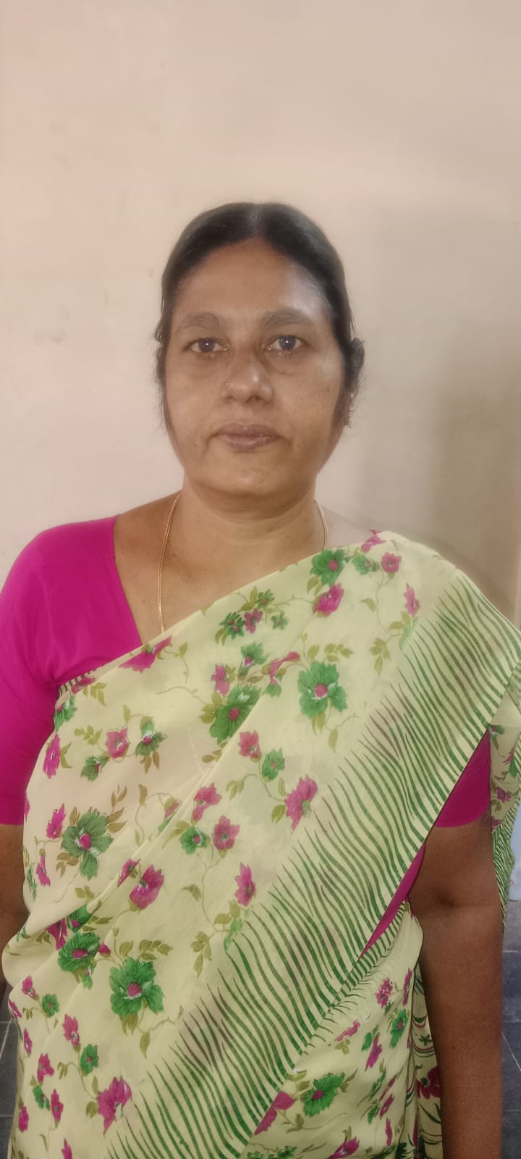 | Smt. T. Janaki | Herbarium Keeper | 10th Class | 23 years

